MOSFET HW 3 (19 points)
(jas, MOSFET HW 3.docx, 12/1/2025)

Clearly indicate answers and include units for numeric answers, using 3 or 4 significant figures. Show at least the major steps of your work so that if necessary partial credit can be awarded.

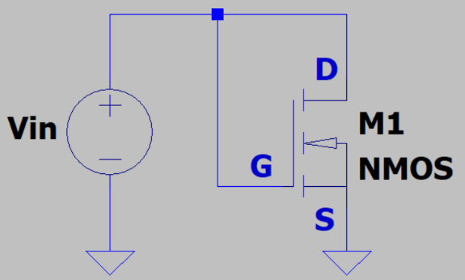
- Determine the voltage V_{in} required to produce a drain current of 0.5 A in the adjacent enhancement mode MOSFET circuit, given V_{T} = 2.0 V, and β_{n} = 120 mA/V².
(3 Points.)

$$I_{D}=\frac{β_{n}}{2}{\left(V_{GS}-V_{T}\right)}^{2}$$

$$V_{GS}=V_{in}=\sqrt{\frac{2I_{D}}{β_{n}}}+V_{T}=\sqrt{\frac{2\left(0.5A\right)}{120*{10}^{-3}A/V^{2}}+2.0V}=4.8868V$$
$$V_{in}=4.8868 V$$

- The AOTFL296L n-channel enhancement mode power MOSFET has a typical threshold voltage V_{T} of 2.9 V and a drain current of 66 A for V_{DS} = V_{GS} = 5 V.

- Using Sah’s equation with the substitution $β_{n}=μ_{n}C_{ox}W/L$, determine β_{n} for this power MOSFET. (2 Points.)
$$I_{D}=\frac{β_{n}}{2}{\left(V_{GS}-V_{T}\right)}^{2}$$
$$β_{n}=\frac{2I_{D}}{{\left(V_{GS}-V_{T}\right)}^{2}}=\frac{2\left(66A\right)}{{\left(5V-2.9V\right)}^{2}}=29.932\frac{A}{V^{2}}$$

$$β_{n}=29.932\frac{A}{V^{2}}$$

- Sah’s equation for the Ohmic region for an n-channel enhancement mode MOSFET is
$$as follows:I_{D}=β_{n}\left[\left(V_{GS}-V_{T}\right)V_{DS}-\frac{V_{DS}^{2}}{2}\right]. Derive an expression for R_{DS\left(On\right)}=\frac{V_{DS}}{I_{D}}$$
in the Ohmic region in terms of $β_{n}$, $V_{GS}, and V_{T}$ from the above equation by neglecting the ${V_{DS}^{2}}/2$ term, which becomes negligible at small $V_{DS}$ voltages.
(2 Points.)
$$R_{DS\left(ON\right)}=\frac{V_{DS}}{I_{D}}=\frac{V_{DS}}{β_{n}[\left(V_{GS}-V_{T}\right)V_{DS}]}=\frac{1}{β_{n}[\left(V_{GS}-V_{T}\right)]}$$
$$R_{DS\left(ON\right)}=\frac{1}{β_{n}[\left(V_{GS}-V_{T}\right)]}$$

- Calculate the drain-to-source on resistance of the AOTFL296L n-channel enhancement mode power MOSFET in the Ohmic region using your previously derived expression for $R_{DS\left(On\right)}$ along with your calculated $β_{n}$ value from part a.
(Hint: Your calculated $R_{DS\left(On\right)}$ value should be between 10 and 20 mΩ.) (2 Points.)
$$R_{DS\left(ON\right)}=\frac{1}{29.932\frac{A}{V^{2}}*\left(5V-2.9V\right)}=0.01591 Ω$$
$$R_{DS\left(ON\right)}=15.91 mΩ$$

- While the AOTFL296L n-channel enhancement mode power MOSFET has impressive drain current specifications, the power dissipation of the TO-220F package will limit the continuous drain current that the transistor can conduct in many applications.

- Using the typical 45 ˚C/W thermal resistance for the TO-220F package, along with the maximum operating junction temperature of 175 ˚C for the AOTFL296L, determine the maximum continuous drain current this transistor can reliably conduct at an ambient temperature of 25 ˚C for a drain-to-source voltage V_{DS} = 5 V. (Hint: Your calculated $I_{D}$ value should be between 0.5 and 1.0 A.) (3 points.)
$$P=IV=I_{DS}V_{DS}$$
$$I_{D}V_{DS}*45°\frac{C}{W}=175°C-25°C$$
$$I_{D}=\frac{175°C-25°C}{45°C/W *5V}=0.6667 A$$
$$I_{D}=0.6667 A$$

- Repeat the previous maximum continuous drain current calculation for the AOTFL296L n-channel enhancement mode MOSFET at an ambient temperature of 25 ˚C for a drain-to-source voltage V_{DS} = 0.2 V. (3 points.)
$$I_{D}=\frac{175°C-25°C}{45°C/W *0.2V}=16.6667 A$$
$$I_{D}=16.6667 A$$

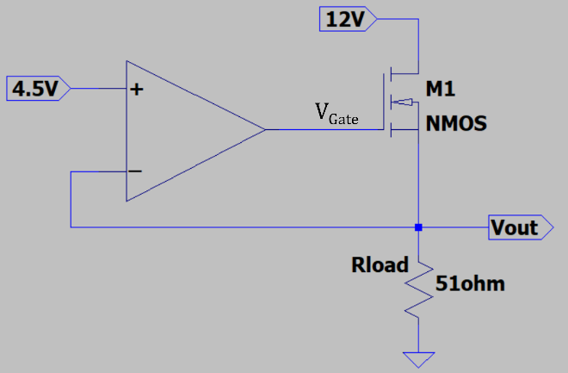
- Determine the voltage V_{Gate} in the adjacent schematic, assuming an ideal op-amp and given that V_{T} = 1.5 V and $β_{n}=200$ mA/V² for the enhancement mode MOSFET M1 operating in transistor saturation. (Hint: Your calculated $V_{Gate}$ value should be between 6.5 and 7.5 V.) (4 Points.)

$$I_{D}=\frac{β_{n}}{2}{\left(V_{GS}-V_{T}\right)}^{2}$$
$$I_{D}=\frac{V_{out}}{R_{load}}=\frac{4.5V}{51Ω}=0.08824 A$$
$$V_{GS}=\sqrt{\frac{2I_{D}}{β_{n}}}+V_{T}=\sqrt{\frac{2\left(0.08824A\right)}{200*\frac{{10}^{-3}mA}{V^{2}}}}+1.5 V=2.439 V$$
$$V_{Gate}=V_{GS}+V_{out}=2.439V+4.5V=6.939V$$
$$V_{Gate}=6.939V$$

